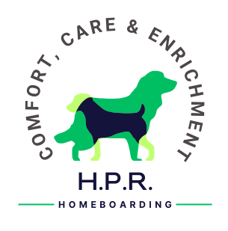

MIXED DOG BOARDING CONSENT FORM

I, the below named client, give the Service Provider permission to board my dog with other dogs that have been mixed prior to the booking and are named below.

I understand that all other clients have also agreed to mixed boarding and that this declaration will be available at all times for review by the licensing authority.

I can confirm that a trial period of familiarisation has taken place which has included one overnight trial stay (when staying longer than three nights in the future) to ensure that there are no issues between any of the animals being cared for and, on this basis, I am happy to go ahead with mixed boarding.

I freely and voluntarily enter into this contract of permission with the Service Provider and fully understand the above conditions.

This permission can be part of the Service Agreement but cannot replace the Service Agreement in part or in full.

I have read the Service Agreement.

FULL NAME:………………………………………………………………………………………………………………………………………………………..

SIGNATURE: ……………………………………………………………………………….…… DATE: ………………………………………………………

SERVICE PROVIDER:………………………………………………………………………………………………………………………………………….…

SIGNATURE: …………………………………………………………………………..……….. DATE: ……………………………………………………..

Client’s Dogs to be boarded with:-
1.
2.
3.
4.
5.

