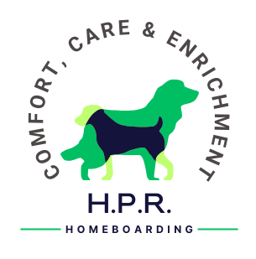
OFF LEAD AGREEMENT

I, , the below named customer, give the Service Providers, Natalie Pettinger and Michael Wheat of H.P.R. Home Boarding, permission to walk my dog(s) off its lead during any walk undertaken during my absence.

I understand the potential consequences that could occur to my dog(s) or to other dogs whilst walking my dog off the lead when in the care of Natalie Pettinger and/or Michael Wheat of H.P.R. Home Boarding.

I agree to release Natalie Pettinger and Michael Wheat of H.P.R. Home Boarding from all liability should my dog become lost, injured, or otherwise harmed because of my dog(s) being walked off the lead.

Natalie Pettinger and Michael Wheat of H.P.R. Home Boarding agree to exercise with all reasonable and due care to prevent injury or death to my dog off the lead - however, in the event of injury/death, except those caused by reckless acts on the part of Natalie Pettinger and Michael Wheat of H.P.R. Home Boarding, Natalie Pettinger and Michael Wheat, the Service Providers, will not be held liable for such injury/death of my dog as a result of off-lead walking.

I freely and voluntarily enter this contract of permission with the Service Providers, Natalie Pettinger and Michael Wheat of H.P.R. Home Boarding and fully understand the above conditions.

Customer Full Name: ___________________________________ Date:

Customer Signature: ___________________________________

Michael Wheat: ___________________________________ Date:
H.P.R. Home Boarding

Natalie Pettinger: ___________________________________ Date:
H.P.R. Home Boarding

